**Project Design Phase-II**

**Technology Stack (Architecture & Stack)**

|  |  |
| --- | --- |
| Date | 29 June 2025 |
| Team ID | LTVIP2025TMID59837 |
| Project Name | Hematovision: Advanced Blood Cell Classification using Transfer Learning |
| Maximum Marks | 4 Marks |

**Technical Architecture:**

The Deliverable shall include the architectural diagram as below and the information as per the table1 & table 2

**Example:** **Helping a Lab Technician Spot Infections Quickly**

**Reference:** <https://in.search.yahoo.com>

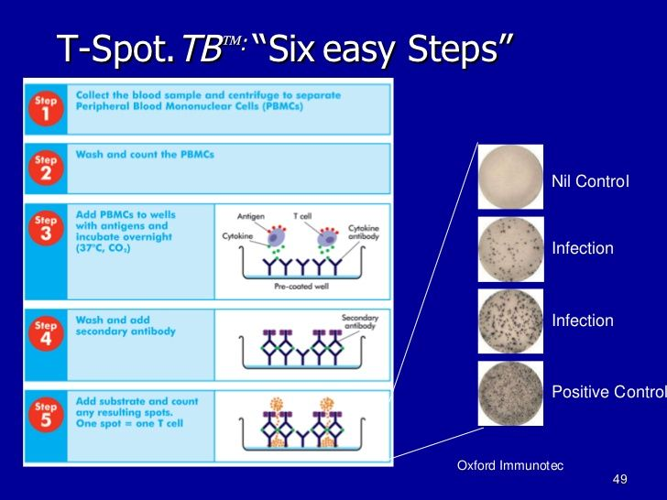

**Table-1: Application Component:**

|  |  |  |  |
| --- | --- | --- | --- |
| **S.No** | **Component** | **Description** | **Technology** |
| 1. | Image Capture & Upload | Microscope captures blood smear images and sends them to the system. | - Digital Microscope - Web upload |
|  | Frontend (User Interface) | Interface for the lab technician to upload images and view results. | - React.js or Vue.js - Tailwind CSS |
|  | Backend API | Handles requests from the frontend | - FastAPI or Flask (Python) |
|  | Image Preprocessing | Prepares images (resize, normalize, denoise) for classification | OpenCV - Pillow (PIL) - NumPy |
|  | Deep Learning Model | Classifies blood cells using a fine-tuned transfer learning model. | - PyTorch or TensorFlow - EfficientNet or ResNet pretrained on ImageNet |
|  | Model Serving | Exposes the trained model to handle real-time predictions. | - TorchServe or TensorFlow Serving - ONNX Runtime |
|  | Cell Detection & Annotation | Highlights and labels each blood cell in the image. | - YOLOv5/YOLOv8 (for detection) - Matplotlib / OpenCV for overlay |
|  | Report Generation | Creates a summary of the cell count and any alerts for abnormal values. | Jinja2 (Python template engine) - WeasyPrint (PDF generation) |
|  | Database | Stores image metadata, classification results, user actions, and reports. | PostgreSQL or MongoDB |
|  | Authentication & Security | Manages user roles (e.g., technician, admin), encrypts data. | - JWT / OAuth2 for login - HTTPS (SSL/TLS) |

**Table-2: Application Characteristics:**

| S.No | Characteristics | Description | Technology |
| --- | --- | --- | --- |
| 1. | Real-time, High-Resolution | Captures high-quality images of blood smear slides via microscope. | - Digital Microscope - USB/HDMI interface |
|  | Lightweight, Fast | Connects frontend with AI model and manages data flow. | - FastAPI or Flask (Python) |
|  | Automated, Accurate | Enhances image quality, normalizes formats for ML model input. | -OpenCV - Pillow |
|  | Transfer Learning, Fine-Tuned | Classifies cell types using pretrained model adapted to blood cell images. | -PyTorch or TensorFlow - EfficientNet, ResNet |

**References:**

<https://proceedings.mlr.press/>

https://in.search.yahoo.com/